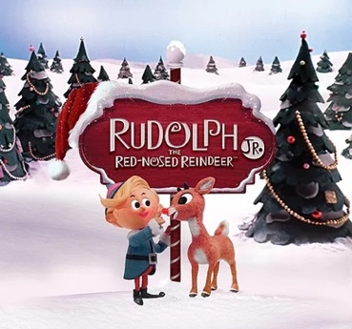
Beach Elementary Rudolph 2025 Production Schedule
September
Date | Time | Plan
17 | 3;40-5:00 | Orientation Audition Prep
24 | 3:40-5:00 | Vocal/Speaking Part Auditions
October
1 | 3:40-5:00 | Scenes 1-13 Read Through
8 | 3:40-5:00 | Scenes 1-6 Christmas Town, Interior of Santa’s Castle, An Icy Pass
15 | 3:40-5:00 | Scenes 7-9 Christmas Town, The Island of Misfit Toys, King Moonracer’s Throne Room
22 | 3:40-5:00 | Scenes 10-11 Christmas Town, Cave of the Abominable Snowmonster
29 | 3:40-5:00 | Scenes 12-13 Interior of Santa’s Castle, The Island of Misfit Toys
November
5 | 3:40-5:30 | Scenes 1-6 Props All Lines and Music Memorized- No Books on Stage
12 | 3:40-5:30 | Scenes 7-13 Props All Lines and Music Memorized- No Books on Stage
19 | 3:40-5:30 | Scenes 1-13 All Lines and Music Memorized- No Books on Stage
December
1 | 3:40-5:30 | Scenes 1-13 All Lines and Music Memorized- No Books on Stage
3 | 3:40-7:00 | Dress Rehearsal (Actors)
4 | 9:30-10:00 | In-School Dress Rehearsal (All 4th Graders)
5 | 2:00-3:15 | In-School Performance
5 | 5:00-8:15 | Evening Performance 7pm (Actors arrive 5:00pm)

Speaking Part Audition: Sam, Santa and Mrs Claus p.2, Boss Elf and Hermey p.33, or Rudolph and Clarice p.25-26, Rudolph and Yukon p.38-39 (choose one) Vocal Audition: “There’s Always Tomorrow” p.26-28, or “A Holly Jolly Christmas” p.3, or “We’re A Couple of Misfits” p.34-35(choose one)

