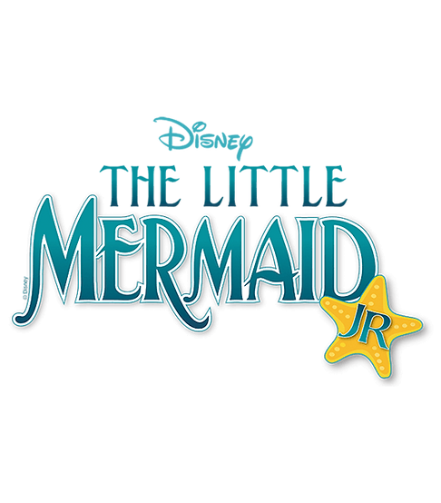

St Leonard Elementary School Musical Theater Club 2025-2026
September 2025
Date | Time | Plan
23 | 4:20-5:45 | Audition Prep-Scripts
30 | 4:20-5:45 | Vocal Auditions: Part of Your World, Under the Sea, Poor Unfortunate Souls (choose one)
October 2025
7 | 4:20-5:45 | Speaking Part Auditions: King Triton, Sebastian p.21-22, Ariel, Ursula p.54-55 (choose one)
14 | 4:20-5:45 | Scenes 1-20 Read through
21 | 4:20-5:45 | Scenes 1-4 Fathoms Below, Daughters of Triton, Human Stuff
28 | 4:20-5:45 | Scenes 5-6 Part of Your World, Under the Sea
November 2025
4 | 4:20-5:45 | Scenes 7-9 Prince Eric’s Ship, The Storm, Part of Your World Reprise 1and 2, She’s In Love
18 | 4:20-5:45 | Scenes 10-12 Poor Unfortunate Souls, Beluga Sevruga
25 | 4:20-5:45 | Scenes 13-14 Les Poissons, One Step Closer
December 2025
2 | 4:20-5:45 | Scenes 15-18 Kiss the Girl, The Contest, Poor Unfortunate Souls Reprise
9 | 4:20-5:45 | Scenes 19-20 The Confrontation, Human Again,Part of Your World Finale
16 | 4:20-5:45 | Scenes 1-10 Choreo Under the Sea

January 2026
Date | Time | Plan
6 | 4:20-5:45 | Scenes 11-15 Choreo She’s In Love
13 | 4:20-5:45 | Scenes 16-18 Choreo Les Poisson
20 | 4:20-5:45 | Scene 1, Finale Curtain Call
27 | 4:20-5:45 | Scenes 19-20 Cast Biographies Due
February 2026
3 | 4:20-5:45 | Scenes 1-10 Cast and Tech Crew
10 | 4:20-5:45 | Scenes 11-20 Cast and Tech Crew
17 | 4:20-5:45 | Scenes 1-10 All Music, Cast and Tech Crew, Pictures
24 | 4:20-5:45 | Scenes 11-20 All Music, Cast and Tech Crew, Tech Crew Biographies Due
March 2026
3 | 4:20-5:45 | Scenes 1-20 All Choreo
7 | 4:00-6:30 Sat | Costume Fitting, Tech Rehearsal (Tech crew 2pm-6:30)
9 | 4:20-7:00 | Dress Rehearsal
11 | 5:30-8:30 | Evening Performance 7 pm
12 | 5:30-8:30 | Evening Performance 7pm
13 | 2:00 | In School Performance

