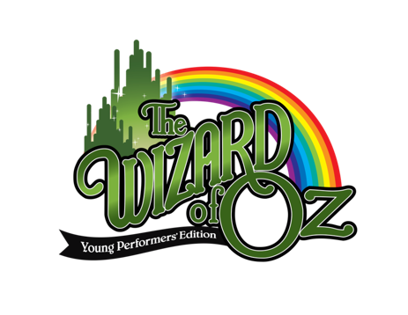
Cast Production Schedule
Rehearsals are Monday’s 3:40 pm – 5:15 pm unless otherwise noted
October 9th Pass out Scripts review audition material and Contracts
October 16th Auditions All Cast
(Somewhere Over The Rainbow, p20-21 Dorothy and Scarecrow)
October 23rd Auditions pm All Cast
October 30th Rehearsal 20 Full Read through
November 6th Rehearsal 19 Scenes 1-2 Outside Gale Farm, Encampment Professor Marvel
November 13th Rehearsal 18 Scene 4 Munchkinland
November 20th Rehearsal 17 Scene 4 Munchkinland
November 27th Rehearsal 16 Scenes 5-6 Cornfield, Apple Orchard
December 4th Rehearsal 15 Scene 7 Dark and Creepy Forest
December 11th Rehearsal 14 Scene 8 The Gates of Emerald City
December 18th Rehearsal 13 Scenes 9 Wizards’s Chamber , 10 Haunted Forest, 11 Witch’s Castle
January 8th Rehearsal 12 Scene 12 Haunted Forest, Scene 13 Witch’s Castle
January 22nd Rehearsal 11 Scene 14 Wizard’s Chamber
January 29th Rehearsal 10 Scene 15 Dorothy’s Bedroom
February 5th Rehearsal 9 Choreography Jitterbug

February 12th Rehearsal 8 Choreography Munchkinland Musical Sequence
No Books on Stage
March 4th Rehearsal 7 Choreography Merry Old Land of Oz
March 11th Rehearsal 6 Choreography Munchkinland Musical Sequence
March 18th Rehearsal 5 Choreography Jitterbug
April 8th Rehearsal 4 Choreography Merry Old Land of Oz
April 15th Rehearsal 3 Choreography
April 22nd Rehearsal 2 Scenes 1-7
April 29th Rehearsal 1 Scenes 8-15
Saturday May 4th All Cast Costume Fitting and Stage Awareness 4:00 pm-7:00 pm
Monday May 6th Tech Dress Rehearsal 3:40 pm-6:40 pm Bring snack (All Cast)
Tuesday May 7th Dress Rehearsal 3:40 pm-7:00 pm – Pizza Provided
Wednesday May 8th In School Performances 9:30 am 1:30 pm
Thursday, May 9th Performance 7:00 pm (Cast Arrives at 5:30 pm)
Friday May 10th Performance 7:00 pm (Cast Arrives at 5:30 pm) Cast Party 8:30 pm – 9:30pm
Saturday May 11th Set Deconstruction & Costume Return 8:00 am-1:00 pm

