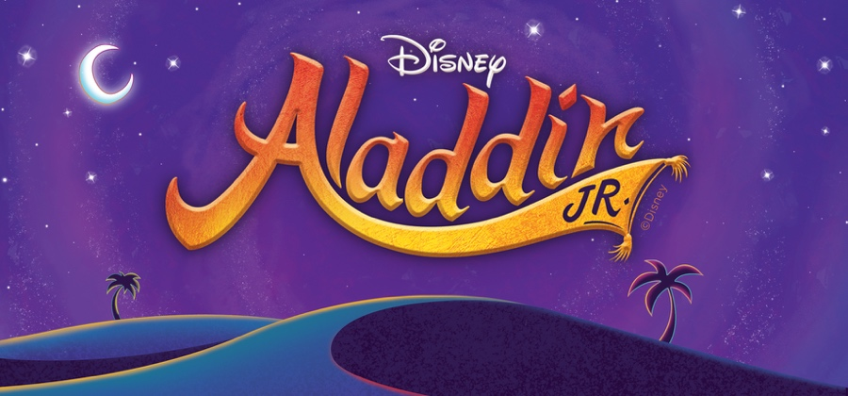

Calvert Elementary School Musical Theater Club 2025-2026
Student Production Schedule

October
Date | Time | Plan
6 | 3:40-5:15 | Audition Prep-Scripts
20 | 3:40-6:00 | Vocal Aud: Friend Like Me p.41, A Whole New World p.64-69, High Adventure p.73-78
27 | 3:40-6:00 | Spk Aud: Aladdin-Jasmine p.30-31, Genie-Aladdin p.40, Iago-Jafar- Sultan p.16-17
November
3 | 3:40-5:15 | Scene 1 The Marketplace, Overture/Arabian Nights, One Jump Ahead
10 | 3:40-5:15 | Scenes 2 -3 The Palace and Marketplace, These Palace Walls, Babbkak, Omar, Kassim
17 | 3:40-5:15 | Scenes 4-6 The Desert and Cave of Wonders, Friend Like Me
24 | 3:40-5:15 | Scene 7 The Palace, Prince Ali
December
1 | 3:40-5:15 | Scene 8 Jasmine’s Balcony, A Whole New World
8 | 3:40-5:15 | Scenes 9-10 The Marketplace, Journey to the Palace, High Adventure
15 | 3:40-5:15 | Scene 11 The Palace, Prince Ali Reprise, Finale
22 | 3:40-5:15 | Scenes 1-11
January
5 | 3:40-5:15 | Scenes 1-3
12 | 3:40-5:15 | Scenes 4-6
26 | 3:40-5:15 | Scene 7

February
Date | Time | Plan
2 | 3:40-5:15 | Scenes 8-9
9 | 3:40-5:15 | Scenes 10-11
23 | 3:40-5:15 | Choreography Friend Like Me, Prince Ali
March
2 | 3:40-5:15 | Scenes 1-6 Tech and Stage Crew Report
9 | 3:40-5:15 | Choreography Arabian Nights, One Jump
16 | 3:40-5:15 | Scenes 7-11 Tech and Stage Crew Report
23 | 3:40-5:15 | All Music
April
13 | 3:40-5:15 | Scenes 1-11 Tech and Stage Crew
Show Week April
17 Fri | 5:00 pm-9:00 pm | Load-In (Adults)
18 Sat | 4:00-6:30 | Costume Fitting, Costume Fitting, Full Run Through(Tech and stage crew 2:00-6:30)
20 Mon | 3:40-7:00 | Dress Rehearsal
21 Tues | 10:00/2:00 | In-School Performances
23 Thurs | 5:00-8:30 pm | Actors arrive at 5pm; Performance at 7pm
24 Fri | 5:00-8:30 pm | Actors arrive at 5pm; Performance at 7pm
25 Sat | 9:00 am-noon | Load-Out

