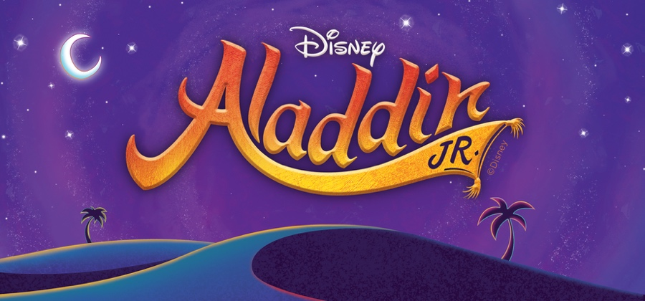

Beach Elementary School Musical Theater Club 2025-2026
Student Production Schedule

December
Date | Time | Plan
6 | 3:40-5:15 | Audition Prep-Scripts
17 Wed | 3:40-6:00 | Vocal Aud: Friend Like Me p.41, A Whole New World p.64-69, High Adventure p.73-78
18 | 3:40-6:00 | Spk Aud: Aladdin-Jasmine p.30-31, Genie-Aladdin p.40, Iago-Jafar- Sultan p.16-17
January
7 | 3:40-5:30 | Scene 1-3 The Marketplace, Overture/Arabian Nights, One Jump Ahead
14 | 3:40-5:30 | Scenes 4 -7 The Palace and Marketplace, These Palace Walls, Babbkak, Omar, Kassim
28 | 3:40-5:30 | Scenes 8-11 The Desert and Cave of Wonders, Friend Like Me
February
4 | 3:40-5:30 | Scene 1-3 The Palace, Prince Ali
18 | 3:40-5:30 | Scene 4-7 Jasmine’s Balcony, A Whole New World
28 | 3:40-5:30 | Scenes 8-11 The Marketplace, Journey to the Palace, High Adventure
March
4 | 3:40-5:30 | Scene 1-5 The Palace, Prince Ali Reprise, Finale
11 | 3:40-5:30 | Scenes 6-11
25 | 3:40-5:30 | Scenes 1-11
31 | 5:00-9:00 | Load-In
Show Week April
4 Sat | 4:00-6:30 | Costume Fitting, Full Run Through(Tech and stage crew 2:00-6:30)
7 Tues | 3:40-7:00 | Dress Rehearsal
8 Wed | 2:00 | In-School Performance
9 Thurs | 2:00 | In-School Performance
9 Thurs | 5:00-8:30 pm | Actors arrive at 5pm; Performance at 7pm
10 Fri | 5:00-8:30 pm | Actors arrive at 5pm; Performance at 7pm
11 Sat | 9:00 am-noon | Load-Out

