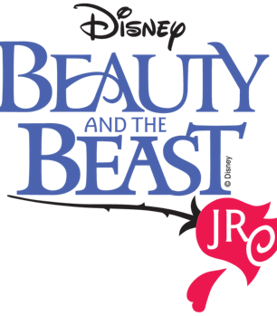

Huntingtown Elementary School Musical Theater Club 2025-2026

Student Production Schedule

November 2025
Date | Time | Plan
6 | 3:40-5:30 | Audition Prep-receive scripts
13 | 3:40-5:30 | Vocal Auditions (Pick One) Belle, Gaston, Beauty and the Beast
20 | 3:40-5:30 | Speaking Audition Belle and Maurice p.16-17 or Lumiere and Cogsworth p.27-28
December 2025
4 | 3:40-5:30 | Read Through
January 2026
7 | 3:40-5:30 | Music Belle,,Belle Reprise
8 | 3:40-5:30 | Prologue The Castle Steps, Scenes 1-2 The Village and Forest
14 | 3:40-5:30 | Music Finale, Belle Reprise
15 | 3:40-5:30 | Scenes 3-4-The Castle and Belle’s Cottage
22 | 3:40-5:30 | Scenes 5-6 The Castle and Tavern- Music Home, Home Tag, Gaston
28 | 3:40-5:30 | Music Gaston Reprise, Be Our Guest
29 | 3:40-5:30 | Scenes 7-8 The Castle and Forest

February 2026
4 | 3:40-5:30 | Music Something There, Human Again
5 | 3:40-5:30 | Scenes 9-10 The Castle and Village
12 | 3:40-5:30 | Scenes 11-12 The Castle and Belle’s Cottage- Music Beauty and the Beast, Mob song
18 | 3:40-5:30 | Music Home Reprise, Finale
19 | 3:40-5:30 | Scene 13 The Castle
25 | 3:40-5:30 | Music Gaston, Gaston Reprise
26 | 3:40-5:30 | Scenes Prologue-7
March 2026
5 | 3:40-5:30 | Music Be Our Guest
12 | 3:40-5:30 | Scenes 9-13 (Costume Fitting for All County Chorus members)
19 | 3:40-5:30 | Music Belle, Finale
21 | 4:00-7:00 | Costume Fitting, Tech Dress Rehearsal Cast (Tech crew 2 pm-7:30)
23 | 3:40-7:30 | Dress Rehearsal
24 | 9:30 am | In-School Performance
24 | 7:00 pm | Evening Performance at 7pm (Students arrive at 5:30)
26 | 1:45 pm | In School Performance
27 | 7:00 pm | Evening Performance at 7pm (Students arrive at 5:30)

